Voice Coach — Análisis de voz
Idioma: English · Duración: 54s · Palabras: 113 · Ritmo: 125 ppm · Positividad: 67% · Muletillas: 1 · Generado: 7/10/2026, 11:25:17 PM

Métricas
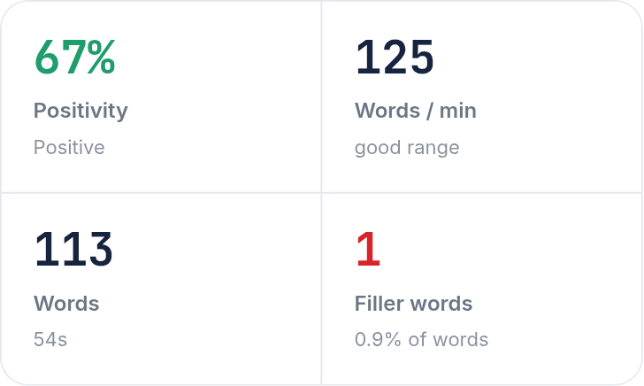

Arco de sentimiento
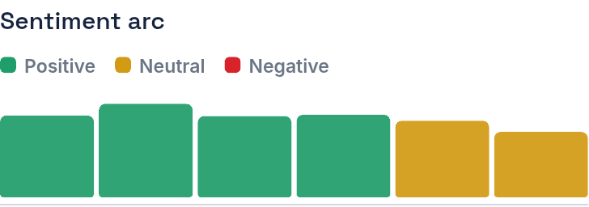

Transcripción
One, I prefer to study alone because you can concentrate and prepare as you want. For example, some people are good in maths, however others like chemical. So everybody can learn as they want. Two, I agree with a foreign languages because now we are in a global economy and we can make a business with other people, for example, a executive from Europe or Asia, compared to Peru to buy fruits and gifts. Three, I want to learn English and later Portuguese, because it's a way to be an international, For example, quandrine, many companies from different countries are looking people in Latin America because they can travel. I decompose less money.
Color del texto — Verde: positivo · Amarillo: neutral · Rojo: negativo

